**Bell Ringer:** Central Dogma FRQ

*AP Biology*

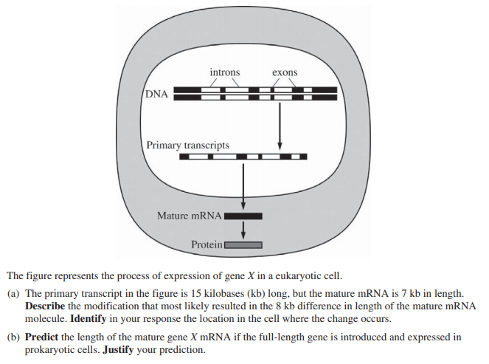

**Bell Ringer:** Central Dogma FRQ

*AP Biology*

